EMAIL MARKETING
AUTOMATION SYSTEM
10 DASHBOARD SCREENSHOTS
Digital Marketing Capstone Project

1. Login Page
Secure entry screen for the Email Marketing Automation System.
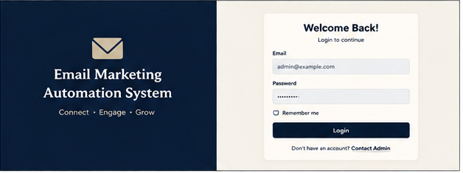

2. Main Dashboard
Overview of subscribers, campaigns, automations and campaign performance.
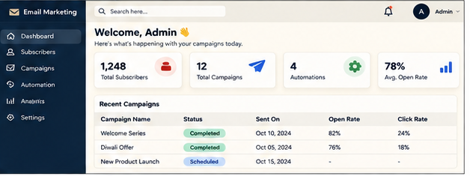

3. Subscriber Management
Subscriber list with customer groups, status and contact-management controls.
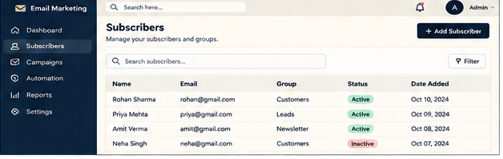

4. Import Contacts (CSV)
CSV contact import screen for adding multiple subscribers at once.
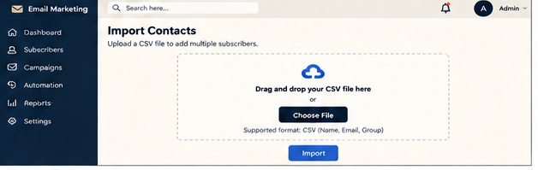

5. Campaign Creation
Campaign creation screen with subject, template, schedule and email preview.
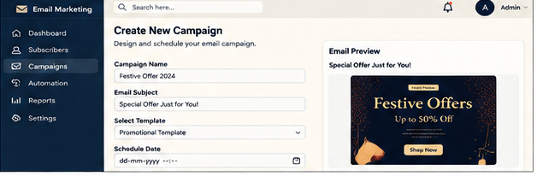

6. Email Templates
Template library for welcome, promotional, newsletter and reminder emails.
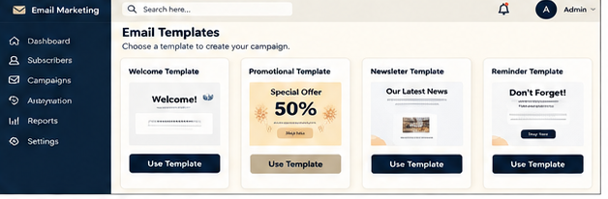

7. Automation Setup
Automation workflow setup for triggers, delays and welcome-email actions.
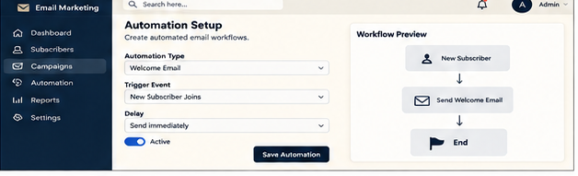

8. Campaign Analytics Dashboard
Campaign analytics showing open rate, click rate, sent emails and engagement trends.
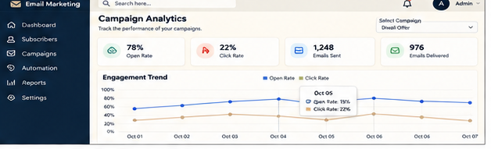

9. Report Generation
Report-generation screen with campaign metrics and CSV export.
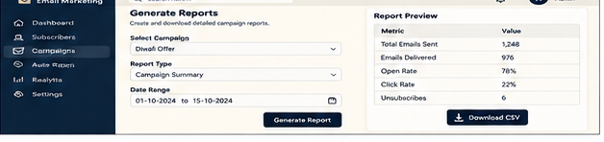

10. Settings - Profile & Preferences
Profile, email, notification and security preference settings.
